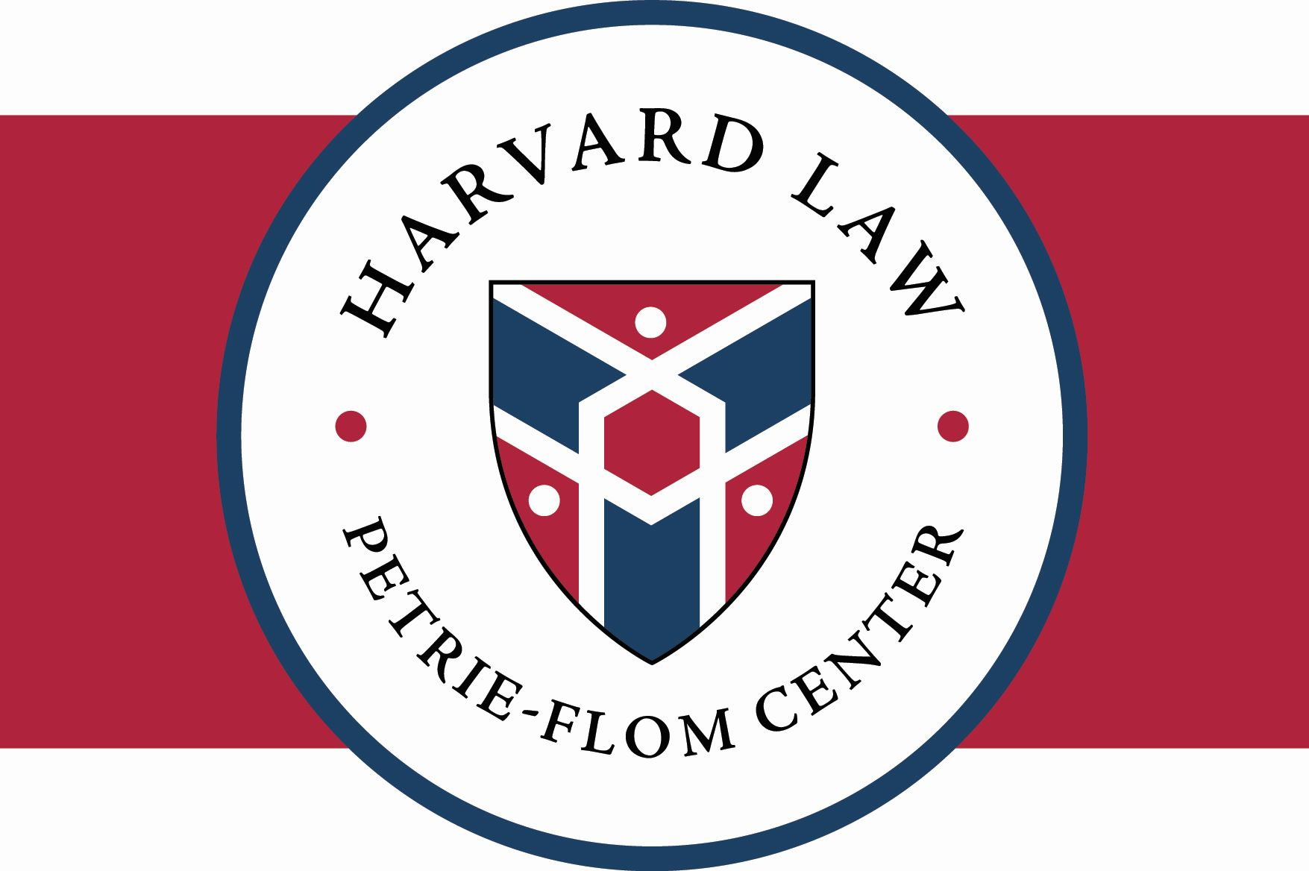

Beyond Disadvantage: Disability, Law, and Bioethics
June 1, 2018
“Congress acknowledged that society’s accumulated myths and fears about disability and disease are as handicapping as are the physical limitations that flow from actual impairment.” Justice William J. Brennan, Jr., School Bd. of Nassau, Fl. v. Arline, 480 U.S. 273 (1973).
The Petrie-Flom Center for Health Law Policy, Biotechnology, and Bioethics at Harvard Law School is pleased to announce plans for our 2018 annual conference, entitled: “Beyond Disadvantage: Disability, Law, and Bioethics.” This year’s conference is organized in collaboration with the Harvard Law School Project on Disability.

Conference Description
Historically and across societies people with disabilities have been stigmatized and excluded from social opportunities on a variety of culturally specific grounds. These justifications include assertions that people with disabilities are biologically defective, less than capable, costly, suffering, or fundamentally inappropriate for social inclusion. Rethinking the idea of disability so as to detach being disabled from inescapable disadvantage has been considered a key to twenty-first century reconstruction of how disablement is best understood.
Such ‘destigmatizing’ has prompted hot contestation about disability. Bioethicists in the ‘destigmatizing’ camp have lined up to present non-normative accounts, ranging from modest to audacious, that characterize disablement as “mere difference” or in other neutral terms. The arguments for their approach range from applications of standards for epistemic justice to insights provided by evolutionary biology. Conversely, other bioethicists vehemently reject such non-normative or “mere difference” accounts, arguing instead for a “bad difference” stance. “Bad difference” proponents contend that our strongest intuitions make us weigh disability negatively. Furthermore, they warn, destigmatizing disability could be dangerous because social support for medical programs that prevent or cure disability is predicated on disability’s being a condition that it is rational to avoid. Construing disability as normatively neutral thus could undermine the premises for resource support, access priorities, and cultural mores on which the practice of medicine depends.
The “mere difference” vs. “bad difference” debate can have serious implications for legal and policy treatment of disability, and shape strategies for allocating and accessing health care. For example, the framing of disability impacts the implementation of the Americans with Disabilities Act, Section 1557 of the Affordable Care Act, and other legal tools designed to address discrimination. The characterization of disability also has health care allocation and accessibility ramifications, such as the treatment of preexisting condition preclusions in health insurance. The aim of the conference is to construct a twenty-first century conception of disablement that resolves the tension about whether being disabled is merely neutral or must be bad, examines and articulates the clinical, philosophical, and practical implications of that determination, and attempts to integrate these conclusions into medical and legal practices.
Call for Abstracts
We seek proposals that offer innovative conceptualizations and advance inventive approaches. Proposals should focus on the fresh contributions the presentation will make, including sketches of the supporting arguments. The abstract should include (but not be limited to) a paragraph summarizing the issue that will be addressed and any currently contending views about its resolution. Successful abstracts will explicitly address how the proposed presentation will address the challenges of integrating legal and medical understandings of disablement.

We welcome submissions on both broad conceptual questions and more specific policy issues related to the “mere difference” vs. “bad difference” debate. Potential topics include:
- Can disability be considered definitively bad, without defining living with a disability as inescapably disadvantageous?
- Can we ameliorate mismatches between the capabilities of people living with disabilities and the socially constructed environment without seeming to privilege them?
- Do the kinds of human diversity that disablement represents threaten the species or harm society? Can they improve the human species or benefit society?
- (How) are bioethicists obligated to represent or at least respect the standpoints of people with disabilities?
- Does the U.S. Supreme Court characterize and categorize disability correctly in the seminal equal protection case, Cleburne v. Cleburne Living Center? How can we reconcile making special or individualized arrangements to avoid excluding individuals based on disability with equal opportunity and equal protection?
- Do different agencies’ and programs’ diverse definitions of disability—for example, that for some programs medical diagnoses suffice for disability status while others demand demonstrations of severe dysfunction—undercut efforts to address disability discrimination?
- What is the standard for people with disabilities having meaningful access to health care? What is the minimum standard for people with disabilities’ access to health care below which denial of care equates to disability discrimination?
- How may protections against disability discrimination—especially claims to civil rights or human rights—most effectively be made operative in the medical clinic?
- Can the processes for accommodating disabilities be secured against fraud?
- How should the impact of differences due to disability affect the way the competence of people with disabilities for accepting or rejecting treatment is assessed? How might new technologies affect courts’ determinations in this regard?
- What progress has been made in increasing the proportion of medical professionals with disabilities and what steps are needed to speed this effort?
- (How) should people with disabilities’ inability to achieve normal functioning affect their priority for scarce or expensive health care?
- Given the current state of data about their risks of morbidity, should lifesaving interventions for extremely preterm infants be harder to obtain than for other babies?
- Can Disability Pride be as effective for “destigmatizing” as earlier expressions of pride made by social movements such as those advanced by the LGBTQi, Women’s, or other groups?
Please note that this list is not meant to be exhaustive; we hope to receive abstracts related to the conference’s central question even if the particular topic was not specifically listed here. Proposals should demonstrate a clear linkage to all three aspects of the conference—disability, bioethics, and law. Papers that focus on ethics should include substantial discussion of policy implications. Relatedly, law will be treated broadly to include governmental policy decisions more generally. Successful abstracts will propose or outline an argument/position, rather than merely stating a topic.

In an effort to encourage interdisciplinary and international dialogue, we welcome submissions from legal scholars and lawyers, bioethicists, philosophers, clinicians, medical researchers, disability rights advocates, public health practitioners, behavioral economists, government officials and staff, and others who have a meaningful contribution to make on this topic. We welcome philosophical and legal reflections from contributors across the world, but these submissions should be general or United States- focused rather than comparative in nature. We welcome submissions from advocacy organizations, think tanks, and others outside academia, but emphasize that this is a scholarly conference, and abstracts/papers will be held to academic standards of argumentation and support.

How to Participate

If you are interested in participating, please send a 1-page abstract of the paper you would plan to present to petrie-flom@law.harvard.edu as soon as possible, but not later than October 15, 2017. If your abstract is selected, your final paper will be due on April 1, 2018, and you will be assigned a presentation slot for the conference. Please note that all presenters must provide a full final draft in order to participate and that presenters are expected to attend the conference for its full duration. We will accept conference papers of all lengths and styles (e.g., law review, medical, philosophy, or policy journal, etc.), but presentations will be limited to 15 minutes. The conference will be held on Friday, June 1, 2018. We will pay travel expenses for presenters who must travel to Cambridge; co-authored papers must name a single presenter.

In the past, we have successfully turned several of our conferences into edited volumes (e.g., with Cambridge, MIT, Johns Hopkins, and Columbia University presses). It is possible, although not guaranteed, that conference presenters will publish their papers with us in an edited volume whose chapters will be limited to 5,000 words, including references. Previous conference participants have been able to publish their submissions in different formats in multiple venues, for example both as a short book chapter and a longer law review article. However, the version that will be used for an edited volume should not have been published previously or be planned to publish separately.

How to Register

Registration information is available here. Attendance is free and open to the public, but space is limited. Stay tuned for the conference agenda, which will be posted to our website once abstracts have been selected.

Questions

Please contact the Petrie-Flom Center with any questions: petrie-flom@law.harvard.edu, 617-496-4662.

Sponsored by the Petrie-Flom Center for Health Law Policy, Biotechnology, and Bioethics at Harvard Law School. This year’s conference is organized in collaboration with the Harvard Law School Project on Disability.

